**Task 1:**



**Task 2:**



**Task 3:**



**Task 4:**

**Task 5:**

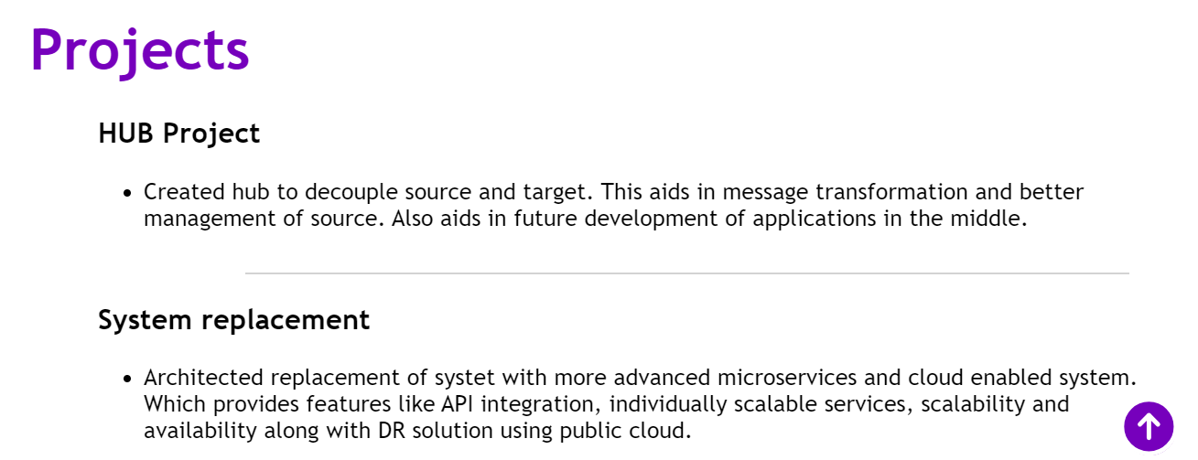

**Task 6:**

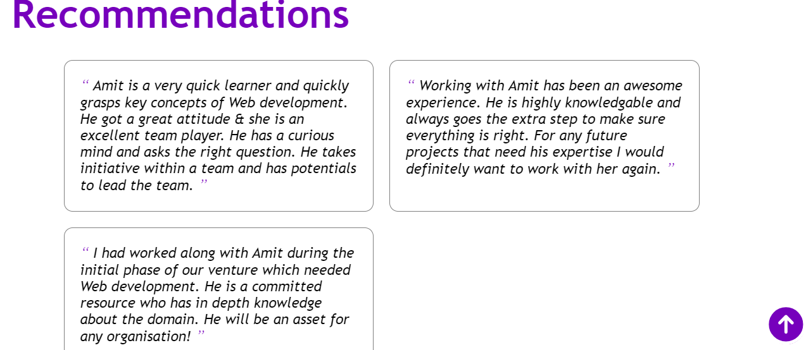

**Task 7:**

**Task 8:**

**Task 9:**

